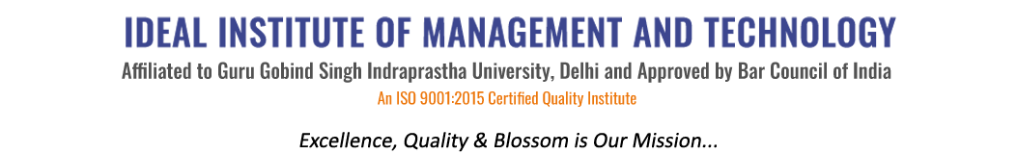
16 X, Karkardooma Institutional Area, (Near Telephone Exchange)
Delhi-110092
+91 (11) 22372639, 22375961,
http://idealinstitute.edu.in
DATE: 16th March, 2016

MINUTES OF THE MEETING
GRIEVANCE

A meeting with Honorable Director along with all the grievance committee members was held in Auditorium 10:00 A.M due to the contingent incident which took place in the college premises and was reported to the grievance committee.

The meeting was conducted on 16-3-2016 and the following actions were taken for the same:
- Each student was given the opportunity to represent their view.
- Each member of the committee verified the incident with each student.
- The footage was extracted.
- With the consensus-ad-idem of the Hon’ble Director and grievance head-7 (4+3) students were suspended w.e.f 16-3-2016 till the enquiry winds up.
Conclusion:
Discipline in-charges of Morning and evening department are desired to activate themselves for controlling such immoral/contingent activities.
Morning Department: Mr Mahesh & Ms Sonal
Evening Department: Mr Mayank & Ms Parminder
With the due permission of Hon’ble Director, the Holi celebrations planned in the coming weeks of both the management shifts stands cancel.
Meeting Chaired By:
Dr. Vineeta Sharma
(Grievance Head)
Meeting Attended by the following:
Ms Shweta Nanda
Ms Renu
Ms Sonal
Ms Anshika
Ms Anjali
Mr Mayank
Ms Gagneet
Dr Shobhit
Ms. Parminder

Drafted By:
Ms Shweta Nanda
(Head-Grievance committee, Morning)

Prof (Dr) Anil Parkash Sharma
Director

